CSE 581

**Lab 11: Views**

*Do this against YOUR own database.*

***For the entire lab, provide all of your SQL as text, inserted at the beginning of the document.***

***For each step also provide a screenshot of execution, showing the SQL and the results.***

***Please make sure both the SQL and the screenshots are marked w/ the question number that they are answering.***

**Steps:**

1. Create a view that will display all of the following columns, joining tables as appropriate:
2. Student First Name
3. Student Last Name
4. Course Title

CREATE VIEW StudentCourses AS

SELECT T.FirstName, T.LastName, C.CourseTitle

FROM

(SELECT FirstName, LastName, CourseId

FROM Users INNER JOIN CourseEnrollment

ON Users.NTID = CourseEnrollment.StudentId)T INNER JOIN Courses C

ON T.CourseId = C.CourseId;

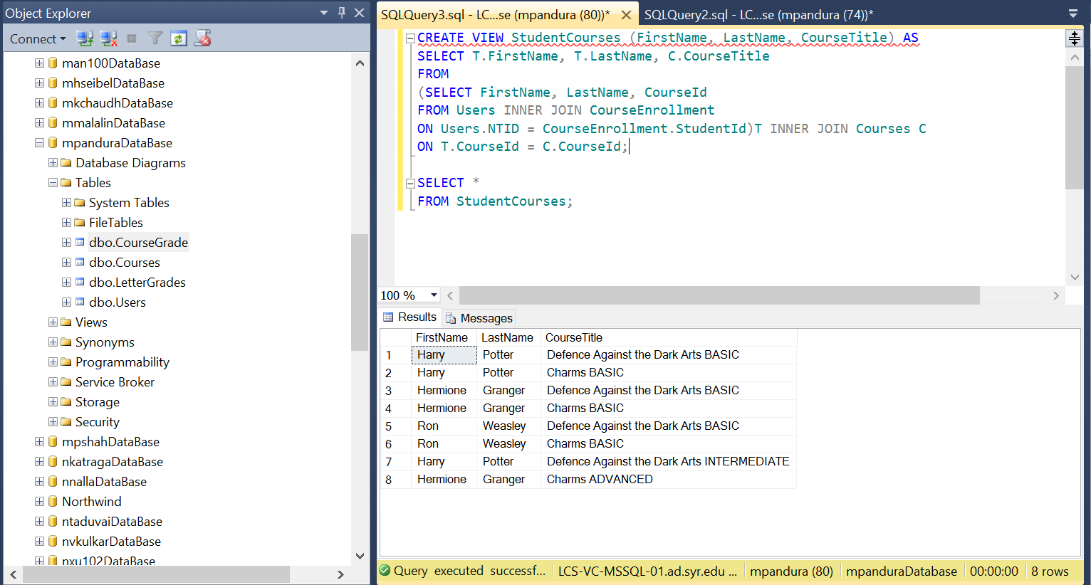

1. Create a view that will display all of the following columns, joining tables as appropriate:
   1. Student First Name
   2. Student Last Name
   3. Course Title
   4. Course Faculty First Name
   5. Course Faculty Last Name
   6. Final Grade (number)

CREATE VIEW CourseDetails (StudentFirstName, StudentLastName, CourseTitle, FacultyFirstName,

FacultyLastName, FinalGrade) AS

SELECT T.FirstName, T.LastName, C.CourseTitle, C.FirstName, C.LastName, T.FinalGrade

FROM (SELECT FirstName, LastName, CourseId, FinalGrade

FROM Users INNER JOIN CourseEnrollment

ON Users.NTID = CourseEnrollment.StudentId) T INNER JOIN

(SELECT FirstName, LastName, CourseId, CourseTitle

FROM Courses INNER JOIN Users

ON Courses.Faculty = Users.NTID) C

ON T.CourseId = C.CourseId;

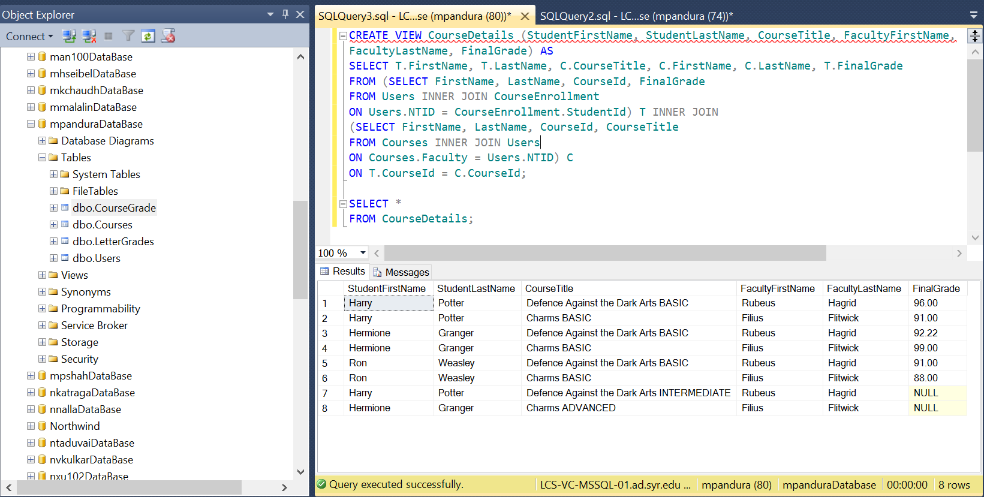

1. Select data from the 2nd view, *for Harry’s classes only*.

SELECT *

FROM CourseSummary

WHERE StudentFirstName LIKE 'Harry';

